## Basics

* operating system
* free
* open source

### History

ken Thompson early 70s UNIX

MULTICS

UNICS

UINX

Linus Torvalds early 90s Linux

Richard Stallman Open source

Next → darwin

### standards

sys V

BSD

### Open source

1. sell the ice-cream, recipe secret
2. sell the ice cream, recipe public
3. free , recipe secret
4. free on sundays, recipe public

firefox

GIMP

Blender

Audacity

Wordpress

Linux

### Unix based systems

Solaris

AIX

Darwin

HP-UX

Xenix

FreeBSD

### Linux based

GNU

Red Hat Linux 1994

OpenSuse

Linux Mint

Fedora Core

Debian Linux

Elementary OS

Arch

Kali Linux

BOSS

Ubuntu

unix-like or linux

## shell

command line interpreter (CLI)

terminal

command prompt

sh

ksh

csh

tcsh

zsh

Fish

bash

### prompt

username@hostname folder

john khut ~

$ normal

>

# root

### command structure

ls

ls -l

command options arguments

command arguments options

### wild cards

*

?

[ ]

### environment variables

SHELL

PWD

PATH

LOGNAME

HOME

## Linux Architecture

### kernel

* core component

process management

creating, scheduling, termination

memory management

allocation, deallocation

device drivers

communication between operating system & hardware devices

system calls & support

interface for user applications to interact with the kernel

### system libraries

special functions

glibc

### system utilities

ls cp

ifconfig top

### user applications

web browsers

text editors

office suites

game

### shell

cli

### File system structure

inverted tree structure

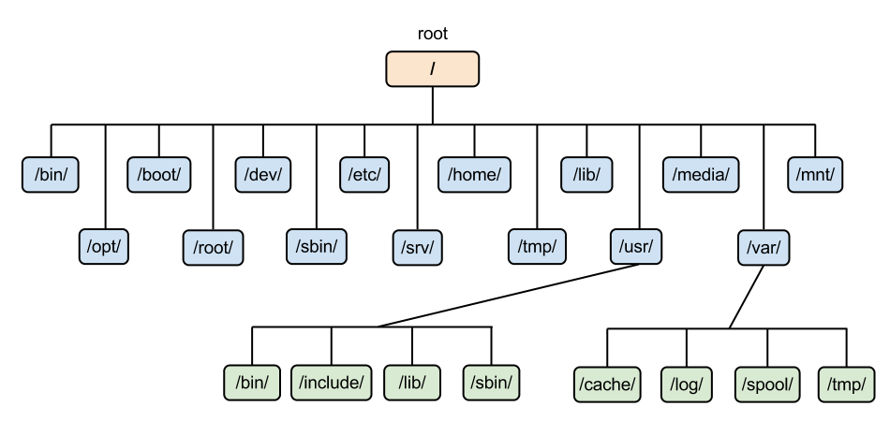

/bin essential command libraries

/etc configuration files

/home user home directory

/lib shared libraries & kernel modules

/usr user utilities & applications

/var variable data files (logs, databases etc.)

/dev device files (device drivers)

### /bootloader

loads the kernel into memory

GRUB

LILO

## basic commands

ls

-l long listing

-a all

pwd

print working directory

clear

clears the terminal screen

date

cal

bc

cd change directory

cd name

cd ..

parent

### getting help

#### whatis

#### man

b

f

search

/text

n next selection

shift+n previous selection

#### - - help

man pages

1 user commands

ls

2 system calls

3 library calls

printf

4 special files

/dev

5 file formats & conventions

6 games

7 miscellaneous

signals

8 system admin

## misc commands

### other

alias

unalias

hostname

uname

ulimit

history

shutdown

### find

-name

-type

d

f

-perm

### pipe |

## files & directories

### file

* unit of data storage

hello hello.txt

text files

.py

.c .cpp

.txt

binary files

#### view

cat

more

less

head

tail

nl

cp copy

-i interactive

-v verbose

mv move

rename

rm remove

-r (recursive for directories)

-f (force)

wc

-l lines

-c characters

-w words

touch

### directory

absolute

&

relative

/usr/bin

cd

.. parent

draintrain draintrain

- toggles

previous

~ home directory

. current directory

mkdir

rmdir (empty)

redirection

> filename

>>

### inode

ls -i

### links

hard links

symbolic links (soft, short)

## editors

GUI editors

CLI editors

vi (vim)

nano

gedit

sublimetext

vscode

emacs

notepad++

gvim

### vi (vim)

insertion mode

i

command mode

esc

:w save

:wq save & quit

:q! quit without saving

:w! save as

u undo

ctrl+r redo

dd cut

delete

p paste

yy copy

7yy copies 7 lines

cc copy

## users and groups

john

jane

root → superuser

### permissions

* modes

trainings_2024.data

jane → owner → user

| permission | | |
| --- | --- | --- |
| user | group | others |
| jane | training | others |
| read write execute | read write ~~execute~~ | read ~~write~~ ~~execute~~ |

avengers.txt

| user | group | others |
| --- | --- | --- |
| u | g | o |
| r w - | r w - | r - - |
| 1 1 0 | 1 1 0 | 1 0 0 |
| 6 | 6 | 4 |

6 6 4

o+w

666

chmod

chown

chgrp

useradd

passwd

groupadd

usermod

## grep

### options

-i

-n

-w

### patterns

(regular expressions)

^ matches the beginning of a line

[ ] matches any one of the enclosed characters

{ } specifies the number of occurrences of the preceding element

{3} occurs three times \{3\}

{1, 4} occurs one to four times

{2,} occurs more than once

$ matches end of a line

### extended

(egrep)

## file system types

Ext (extended file system)

journaling

ext4

XFS

FAT32 (exFAT)

VFS

(virtual file system)

procfs (process file system)

## boot

1. BIOS/UEFI initialization

* BIOS
* UEFI (unified extensible firmware interface)
* hardware initialization
* POST
* system’s firmware
* configure hardware components
* identify bootable devices

1. Bootloader Stage

GRUB

LILO

* stage 1: BIOS?UEFI loads the 1st stage of the bootloader from MBR
* stage 2: menu to the user (if configured)

load the linux kernel and initial RAM disk (initramfs/initrd) into memory

1. Kernel Initialization

loaded the kernel

hardware initialization

mount the root file system

loading initial RAM disk

1. INIT system
2. init system

/etc/init.d

1. systemd (modern)

/etc/systemd

5. User space initialization

* starting user services
* launch login prompts
* user login
  + desktop or shell is started

imp files

GRUB configuration

kernel image

## process

PID

info about process:

blocked signals

process state

CPU registers

username

group id

% CPU

running since

launch time

number of threads

pid (process id)

ppid (parent possess id)

VIRT or VSZ

RSS

% memory

TTY

list of files

### ps

-a (all) hidden in the shell

-A all process in the system

-aux more columns of all process in the system

-ef all process in the system with different set of columns

-ax all process in the system with different set of columns

-C search for a process by name

-o customising the output columns

pid process id

ppid parent process id

tty terminal ids

%cpu

%mem

time “critical”

stime system time when it was launched

etime overall elapsed time

cmd the command or executable used to launch

pri priority of the process

user

stat state of the process

lwp thread ids

nlwp number of threads

### states

run R actively using the cpu

sleep (wait) S waiting for an event to happen

waiting for a timer to get over

stop T paused & sent to the background

kernel I kernel based process

D

zombie Z

subscripts

+ needs stdout

s session leader

### other commands

kill

### signals

| **signal** | **sent from keyboard** | **can be ignored?** |  | **default action** |
| --- | --- | --- | --- | --- |
| SIGTERM | no | yes | 15 | terminate the process |
| SIGINT | ctrl + C | yes | 2 | terminate the process |
| SIGKILL | no | no | 9 | terminate the process |
| SIGSTOP | ctrl + Z | no |  | put it into “stop” state |
| SIGCONT | no | yes |  | continue a process |
| SIGSEGV | no | yes |  | segmentation fault |

default SIGTERM

### background process

1. background of entire system

daemon

1. background of a shell

### jobs

jobs

fg

### files

file descriptors

lowest available

temporary

fd

0 stdin

1 stdout

2 stderr

3 filea.txt

4 fileb.txt

a.out shell

0 -> 0

1 -> 1

2 -> 2

orphan

* gets adopted by some other process

session leader

* all process under it also die

### other commands

pidof

pkill

stark_arya

stark_sansa

stark_bran

snow_john

stark_tony

stark_robb

pkill stark

pstree

top

nice

renice